SIKAP

Case Processing Summary
 | Cases
 | Valid |  | Missing |  | Total
 | N | Percent | N | Percent | N | Percent
Intervensi * Sikap | 54 | 100.0% | 0 | 0.0% | 54 | 100.0%

Intervensi * Sikap Crosstabulation
 |  |  | Sikap |  | Total
 |  |  | Positif | Negatif | Total
Intervensi | Tanpa Booklet | Count | 7 | 20 | 27
Intervensi | Tanpa Booklet | Expected Count | 13.0 | 14.0 | 27.0
Intervensi | Booklet | Count | 19 | 8 | 27
Intervensi | Booklet | Expected Count | 13.0 | 14.0 | 27.0
Total |  | Count | 26 | 28 | 54
 |  | Expected Count | 26.0 | 28.0 | 54.0

Chi-Square Tests
 | Value | df | Asymptotic Significance (2-sided) | Exact Sig. (2-sided) | Exact Sig. (1-sided)
Pearson Chi-Square | 10.681ª | 1 | .001
Continuity Correction^{b} | 8.975 | 1 | .003
Likelihood Ratio | 11.067 | 1 | .001
Fisher's Exact Test |  |  |  | .002 | .001
Linear-by-Linear Association | 10.484 | 1 | .001
N of Valid Cases | 54
a. 0 cells (0.0%) have expected count less than 5. The minimum expected count is 13.00.
b. Computed only for a 2x2 table

PENGETAHUAN

Case Processing Summary
 | Cases
 | Valid |  | Missing |  | Total
 | N | Percent | N | Percent | N | Percent
Intervensi * Pengetahuan | 54 | 100.0% | 0 | 0.0% | 54 | 100.0%

Intervensi * Pengetahuan Crosstabulation
 |  |  | Pengetahuan |  |  | Total
 |  |  | Baik | Cukup | kurang | Total
Intervensi | Tanpa Booklet | Count | 10 | 12 | 5 | 27
Intervensi | Tanpa Booklet | Expected Count | 18.5 | 6.0 | 2.5 | 27.0
Intervensi | Booklet | Count | 27 | 0 | 0 | 27
Intervensi | Booklet | Expected Count | 18.5 | 6.0 | 2.5 | 27.0
Total |  | Count | 37 | 12 | 5 | 54
 |  | Expected Count | 37.0 | 12.0 | 5.0 | 54.0

Chi-Square Tests
 | Value | df | Asymptotic Significance (2-sided)
Pearson Chi-Square | 24.811ª | 2 | .000
Likelihood Ratio | 31.679 | 2 | .000
Linear-by-Linear Association | 20.621 | 1 | .000
N of Valid Cases | 54
a. 2 cells (33.3%) have expected count less than 5. The minimum expected count is 2.50.

Two-Sample Kolmogorov-Smirnov Test

Frequencies
 | Intervensi | N
Pengetahuan | Tanpa Booklet | 27
Pengetahuan | Booklet | 27
Pengetahuan | Total | 54

Test Statisticsª
 |  | Pengetahuan
Most Extreme Differences | Absolute | .630
Most Extreme Differences | Positive | .000
Most Extreme Differences | Negative | -.630
Kolmogorov-Smirnov Z |  | 2.313
Asymp. Sig. (2-tailed) |  | .000
a. Grouping Variable: Intervensi

Frequencies

Notes
Output Created |  | 11-NOV-2020 14:38:59
Comments
Input | Data | C:\Users\user\Documents\PENELITIAN RISBINAKES 2020\KOSMETIK\hasil\booklet kosmetik.sav
Input | Active Dataset | DataSet1
Input | Filter | <none>
Input | Weight | <none>
Input | Split File | <none>
Input | N of Rows in Working Data File | 54
Missing Value Handling | Definition of Missing | User-defined missing values are treated as missing.
Missing Value Handling | Cases Used | Statistics are based on all cases with valid data.
Syntax |  | FREQUENCIES VARIABLES=skorpengetahuan  /FORMAT=NOTABLE  /STATISTICS=STDDEV VARIANCE MINIMUM MAXIMUM MEAN MEDIAN MODE SKEWNESS SESKEW KURTOSIS SEKURT  /HISTOGRAM NORMAL  /ORDER=ANALYSIS.
Resources | Processor Time | 00:00:00,83
Resources | Elapsed Time | 00:00:01,03

Statistics
Skor Pengetahuan
N | Valid | 54
N | Missing | 0
Mean |  | 78.91
Median |  | 89.00
Mode |  | 89
Std. Deviation |  | 21.181
Variance |  | 448.614
Skewness |  | -1.246
Std. Error of Skewness |  | .325
Kurtosis |  | 1.401
Std. Error of Kurtosis |  | .639
Minimum |  | 11
Maximum |  | 100

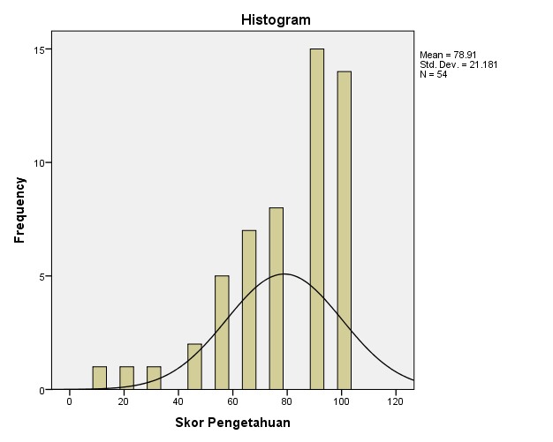

Frequencies

Notes
Output Created |  | 11-NOV-2020 14:39:56
Comments
Input | Data | C:\Users\user\Documents\PENELITIAN RISBINAKES 2020\KOSMETIK\hasil\booklet kosmetik.sav
Input | Active Dataset | DataSet1
Input | Filter | <none>
Input | Weight | <none>
Input | Split File | <none>
Input | N of Rows in Working Data File | 54
Missing Value Handling | Definition of Missing | User-defined missing values are treated as missing.
Missing Value Handling | Cases Used | Statistics are based on all cases with valid data.
Syntax |  | FREQUENCIES VARIABLES=skorsikap  /FORMAT=NOTABLE  /STATISTICS=STDDEV VARIANCE MINIMUM MAXIMUM MEAN MEDIAN MODE SKEWNESS SESKEW KURTOSIS SEKURT  /HISTOGRAM NORMAL  /ORDER=ANALYSIS.
Resources | Processor Time | 00:00:00,48
Resources | Elapsed Time | 00:00:00,72

Statistics
Skor Sikap
N | Valid | 54
N | Missing | 0
Mean |  | 83.87
Median |  | 83.00
Mode |  | 92
Std. Deviation |  | 9.068
Variance |  | 82.228
Skewness |  | -.232
Std. Error of Skewness |  | .325
Kurtosis |  | -.843
Std. Error of Kurtosis |  | .639
Minimum |  | 64
Maximum |  | 100

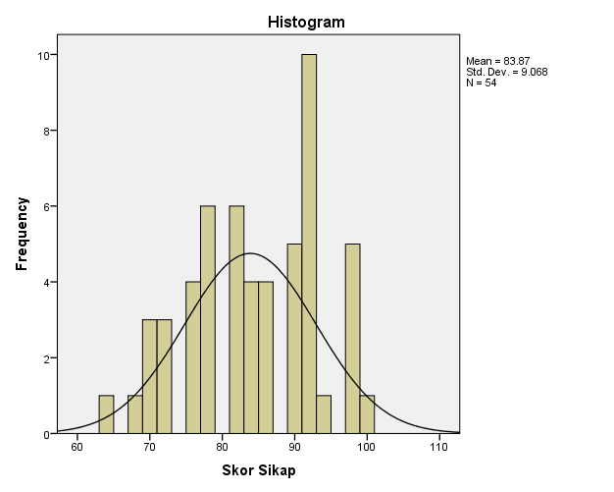

Normalitas pengetahuan

Case Processing Summary
 | Cases
 | Valid |  | Missing |  | Total
 | N | Percent | N | Percent | N | Percent
Skor Pengetahuan | 54 | 100.0% | 0 | 0.0% | 54 | 100.0%

Descriptives
 |  |  | Statistic | Std. Error
Skor Pengetahuan | Mean |  | 78.91 | 2.882
Skor Pengetahuan | 95% Confidence Interval for Mean | Lower Bound | 73.13
Skor Pengetahuan | 95% Confidence Interval for Mean | Upper Bound | 84.69
Skor Pengetahuan | 5% Trimmed Mean |  | 80.97
Skor Pengetahuan | Median |  | 89.00
Skor Pengetahuan | Variance |  | 448.614
Skor Pengetahuan | Std. Deviation |  | 21.181
Skor Pengetahuan | Minimum |  | 11
Skor Pengetahuan | Maximum |  | 100
Skor Pengetahuan | Range |  | 89
Skor Pengetahuan | Interquartile Range |  | 33
Skor Pengetahuan | Skewness |  | -1.246 | .325
Skor Pengetahuan | Kurtosis |  | 1.401 | .639

Tests of Normality
 | Kolmogorov-Smirnovª |  |  | Shapiro-Wilk
 | Statistic | df | Sig. | Statistic | df | Sig.
Skor Pengetahuan | .220 | 54 | .000 | .858 | 54 | .000
a. Lilliefors Significance Correction

Skor Pengetahuan

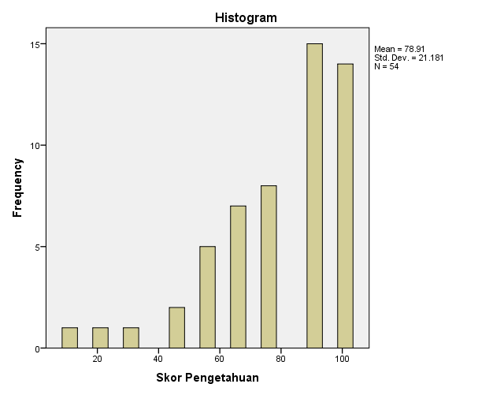

Normalitas sikap

Case Processing Summary
 | Cases
 | Valid |  | Missing |  | Total
 | N | Percent | N | Percent | N | Percent
Sikap | 54 | 100.0% | 0 | 0.0% | 54 | 100.0%

Descriptives
 |  |  | Statistic | Std. Error
Sikap | Mean |  | 1.52 | .069
Sikap | 95% Confidence Interval for Mean | Lower Bound | 1.38
Sikap | 95% Confidence Interval for Mean | Upper Bound | 1.66
Sikap | 5% Trimmed Mean |  | 1.52
Sikap | Median |  | 2.00
Sikap | Variance |  | .254
Sikap | Std. Deviation |  | .504
Sikap | Minimum |  | 1
Sikap | Maximum |  | 2
Sikap | Range |  | 1
Sikap | Interquartile Range |  | 1
Sikap | Skewness |  | -.076 | .325
Sikap | Kurtosis |  | -2.072 | .639

Tests of Normality
 | Kolmogorov-Smirnovª |  |  | Shapiro-Wilk
 | Statistic | df | Sig. | Statistic | df | Sig.
Sikap | .349 | 54 | .000 | .636 | 54 | .000
a. Lilliefors Significance Correction

Sikap

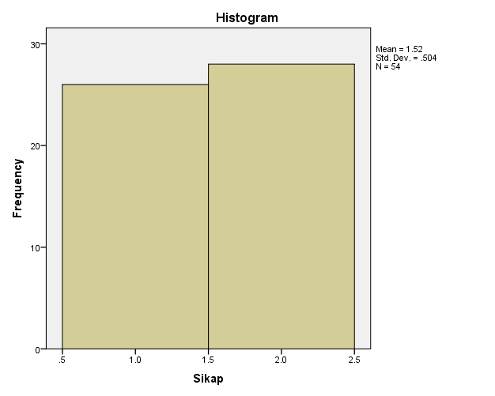

T Test pengetahuan

T-Test

Group Statistics
 | Intervensi | N | Mean | Std. Deviation | Std. Error Mean
Skor Pengetahuan | Tanpa Booklet | 27 | 65.19 | 21.379 | 4.114
Skor Pengetahuan | Booklet | 27 | 92.63 | 8.144 | 1.567

Independent Samples Test
 |  | Levene's Test for Equality of Variances |  | t-test for Equality of Means
 |  | F | Sig. | t | df | Sig. (2-tailed) | Mean Difference | Std. Error Difference | 95% Confidence Interval of the Difference
 |  |  |  |  |  |  |  |  | Lower | Upper
Skor Pengetahuan | Equal variances assumed | 10.995 | .002 | -6.233 | 52 | .000 | -27.444 | 4.403 | -36.279 | -18.609
Skor Pengetahuan | Equal variances not assumed |  |  | -6.233 | 33.389 | .000 | -27.444 | 4.403 | -36.398 | -18.491

Normalitas pengetahuan

Intervensi

Case Processing Summary
 | Intervensi | Cases
 | Intervensi | Valid |  | Missing |  | Total
 | Intervensi | N | Percent | N | Percent | N | Percent
Skor Pengetahuan | Tanpa Booklet | 27 | 100.0% | 0 | 0.0% | 27 | 100.0%
Skor Pengetahuan | Booklet | 27 | 100.0% | 0 | 0.0% | 27 | 100.0%

Descriptives
 | Intervensi |  |  | Statistic | Std. Error
Skor Pengetahuan | Tanpa Booklet | Mean |  | 65.19 | 4.114
Skor Pengetahuan | Tanpa Booklet | 95% Confidence Interval for Mean | Lower Bound | 56.73
Skor Pengetahuan | Tanpa Booklet | 95% Confidence Interval for Mean | Upper Bound | 73.64
Skor Pengetahuan | Tanpa Booklet | 5% Trimmed Mean |  | 66.26
Skor Pengetahuan | Tanpa Booklet | Median |  | 67.00
Skor Pengetahuan | Tanpa Booklet | Variance |  | 457.080
Skor Pengetahuan | Tanpa Booklet | Std. Deviation |  | 21.379
Skor Pengetahuan | Tanpa Booklet | Minimum |  | 11
Skor Pengetahuan | Tanpa Booklet | Maximum |  | 100
Skor Pengetahuan | Tanpa Booklet | Range |  | 89
Skor Pengetahuan | Tanpa Booklet | Interquartile Range |  | 22
Skor Pengetahuan | Tanpa Booklet | Skewness |  | -.755 | .448
Skor Pengetahuan | Tanpa Booklet | Kurtosis |  | .516 | .872
Skor Pengetahuan | Booklet | Mean |  | 92.63 | 1.567
Skor Pengetahuan | Booklet | 95% Confidence Interval for Mean | Lower Bound | 89.41
Skor Pengetahuan | Booklet | 95% Confidence Interval for Mean | Upper Bound | 95.85
Skor Pengetahuan | Booklet | 5% Trimmed Mean |  | 93.07
Skor Pengetahuan | Booklet | Median |  | 89.00
Skor Pengetahuan | Booklet | Variance |  | 66.319
Skor Pengetahuan | Booklet | Std. Deviation |  | 8.144
Skor Pengetahuan | Booklet | Minimum |  | 77
Skor Pengetahuan | Booklet | Maximum |  | 100
Skor Pengetahuan | Booklet | Range |  | 23
Skor Pengetahuan | Booklet | Interquartile Range |  | 11
Skor Pengetahuan | Booklet | Skewness |  | -.653 | .448
Skor Pengetahuan | Booklet | Kurtosis |  | -.766 | .872

Tests of Normality
 | Intervensi | Kolmogorov-Smirnovª |  |  | Shapiro-Wilk
 | Intervensi | Statistic | df | Sig. | Statistic | df | Sig.
Skor Pengetahuan | Tanpa Booklet | .163 | 27 | .062 | .937 | 27 | .103
Skor Pengetahuan | Booklet | .299 | 27 | .000 | .774 | 27 | .000
a. Lilliefors Significance Correction

NORMALITAS SIKAP

Intervensi

Case Processing Summary
 | Intervensi | Cases
 | Intervensi | Valid |  | Missing |  | Total
 | Intervensi | N | Percent | N | Percent | N | Percent
Skor Sikap | Tanpa Booklet | 27 | 100.0% | 0 | 0.0% | 27 | 100.0%
Skor Sikap | Booklet | 27 | 100.0% | 0 | 0.0% | 27 | 100.0%

Descriptives
 | Intervensi |  |  | Statistic | Std. Error
Skor Sikap | Tanpa Booklet | Mean |  | 79.81 | 1.671
Skor Sikap | Tanpa Booklet | 95% Confidence Interval for Mean | Lower Bound | 76.38
Skor Sikap | Tanpa Booklet | 95% Confidence Interval for Mean | Upper Bound | 83.25
Skor Sikap | Tanpa Booklet | 5% Trimmed Mean |  | 79.70
Skor Sikap | Tanpa Booklet | Median |  | 78.00
Skor Sikap | Tanpa Booklet | Variance |  | 75.387
Skor Sikap | Tanpa Booklet | Std. Deviation |  | 8.683
Skor Sikap | Tanpa Booklet | Minimum |  | 64
Skor Sikap | Tanpa Booklet | Maximum |  | 97
Skor Sikap | Tanpa Booklet | Range |  | 33
Skor Sikap | Tanpa Booklet | Interquartile Range |  | 11
Skor Sikap | Tanpa Booklet | Skewness |  | .251 | .448
Skor Sikap | Tanpa Booklet | Kurtosis |  | -.352 | .872
Skor Sikap | Booklet | Mean |  | 87.93 | 1.467
Skor Sikap | Booklet | 95% Confidence Interval for Mean | Lower Bound | 84.91
Skor Sikap | Booklet | 95% Confidence Interval for Mean | Upper Bound | 90.94
Skor Sikap | Booklet | 5% Trimmed Mean |  | 88.18
Skor Sikap | Booklet | Median |  | 92.00
Skor Sikap | Booklet | Variance |  | 58.071
Skor Sikap | Booklet | Std. Deviation |  | 7.620
Skor Sikap | Booklet | Minimum |  | 72
Skor Sikap | Booklet | Maximum |  | 100
Skor Sikap | Booklet | Range |  | 28
Skor Sikap | Booklet | Interquartile Range |  | 9
Skor Sikap | Booklet | Skewness |  | -.686 | .448
Skor Sikap | Booklet | Kurtosis |  | -.254 | .872

Tests of Normality
 | Intervensi | Kolmogorov-Smirnovª |  |  | Shapiro-Wilk
 | Intervensi | Statistic | df | Sig. | Statistic | df | Sig.
Skor Sikap | Tanpa Booklet | .112 | 27 | .200* | .969 | 27 | .563
Skor Sikap | Booklet | .222 | 27 | .001 | .921 | 27 | .042
*. This is a lower bound of the true significance.
a. Lilliefors Significance Correction

T test sikap

Group Statistics
 | Intervensi | N | Mean | Std. Deviation | Std. Error Mean
Skor Sikap | Tanpa Booklet | 27 | 79.81 | 8.683 | 1.671
Skor Sikap | Booklet | 27 | 87.93 | 7.620 | 1.467

Independent Samples Test
 |  | Levene's Test for Equality of Variances |  | t-test for Equality of Means
 |  | F | Sig. | t | df | Sig. (2-tailed) | Mean Difference | Std. Error Difference | 95% Confidence Interval of the Difference
 |  |  |  |  |  |  |  |  | Lower | Upper
Skor Sikap | Equal variances assumed | .170 | .682 | -3.648 | 52 | .001 | -8.111 | 2.223 | -12.572 | -3.650
Skor Sikap | Equal variances not assumed |  |  | -3.648 | 51.139 | .001 | -8.111 | 2.223 | -12.574 | -3.648

Mann Whitney pengetahuan

Mann-Whitney Test

Ranks
 | Intervensi | N | Mean Rank | Sum of Ranks
Skor Pengetahuan | Tanpa Booklet | 27 | 16.80 | 453.50
Skor Pengetahuan | Booklet | 27 | 38.20 | 1031.50
Skor Pengetahuan | Total | 54

Test Statisticsª
 | Skor Pengetahuan
Mann-Whitney U | 75.500
Wilcoxon W | 453.500
Z | -5.113
Asymp. Sig. (2-tailed) | .000
a. Grouping Variable: Intervensi

Two-Sample Kolmogorov-Smirnov Test
Umur

Frequencies
 | Intervensi | N
umur | Tanpa Booklet | 27
umur | Booklet | 27
umur | Total | 54

Test Statisticsª
 |  | umur
Most Extreme Differences | Absolute | .222
Most Extreme Differences | Positive | .000
Most Extreme Differences | Negative | -.222
Kolmogorov-Smirnov Z |  | .816
Asymp. Sig. (2-tailed) |  | .518
a. Grouping Variable: Intervensi

Frequencies
 | Intervensi | N
paritas | Tanpa Booklet | 27
paritas | Booklet | 27
paritas | Total | 54

Test Statisticsª
 |  | paritas
Most Extreme Differences | Absolute | .556
Most Extreme Differences | Positive | .000
Most Extreme Differences | Negative | -.556
Kolmogorov-Smirnov Z |  | 2.041
Asymp. Sig. (2-tailed) |  | .000
a. Grouping Variable: Intervensi

