EFFORTS TO PREVENT THE TRANSMISSION OF COVID-19 THROUGH A CLEAN AND HEALTHY LIFESTYLE IN KALIBAGOR REGENCY HOUSING
KALIBAGOR SUB-DISTRICT

Aris Fitriani
1, Maisje Marlyn Kuhu2

1-2 Poltekkes Kemenkes Semarang
Email: arisfitriyani@poltekkes-smg.ac.id
ABSTRACT
Data for March 31, 2020 showed that there were 1,528 confirmed cases of COVID-19 and 136 deaths in Indonesia. The COVID-19 mortality rate in Indonesia is 8.9%, this figure is the highest in Southeast Asia. This COVID-19 disease can be prevented by implementing a Clean and Healthy Lifestyle as a way to prevent COVID-19. The goal after socialization and education, is expected to be as an effort to prevent the transmission of COVID-19 through Clean and Healthy Living Behavior (PHBS) in Kalibagor Regency Housing, Kalibagor Village, Kalibagor District. The activities carried out were in the form of socializing the prevention of transmission of COVID-19 with PHBS with education through the WhatsApp (WA) group, installing posters and banners, distributing masks, and distributing simple hand washing facilities, distributing children's story books in the environment around the Kalibagor Regency Housing Complex, Kalibagor Village, District Calibagor and cooperate. There is an increase in knowledge and awareness about preventing the transmission of COVID-19 through Clean and Healthy Living Behavior (PHBS) at Kalibagor Regency Housing, Kalibagor Village, Kalibagor District.

Keywords: Prevention of transmission of COVID-19, Clean and Healthy Lifestyle, Residents of Kalibagor Regency Housing

ABSTRACT

Data on March 31, 2020 showed that there were 1,528 confirmed cases of COVID-19 and 136 deaths in Indonesia. The mortality rate of COVID-19 in Indonesia is 8.9%, this figure is the highest in Southeast Asia. This COVID-19 disease can be prevented by implementing a Clean and Healthy Lifestyle as one of the efforts to prevent COVID-19. The goal after socialization and education is expected to be an effort to prevent the transmission of COVID-19 through Clean and Healthy Lifestyle Behavior (PHBS)
at the Kalibagor Regency Housing, Kalibagor Village, Kalibagor District. The activities carried out were in the form of socializing the prevention of COVID-19 transmission with PHBS with education through WhatsApp (WA) groups, installing posters and banners, distributing masks, and distributing simple hand washing facilities, distributing children's story books in the environment around the Kalibagor Regency Housing, Kalibagor Village, Subdistrict. Kalibagor and collaborate. There is an increase in knowledge and awareness about preventing the transmission of COVID-19 through Clean and Healthy Living Behavior (PHBS) at the Kalibagor Regency Housing, Kalibagor Village, Kalibagor District.

Keywords: Prevention of COVID-19 transmission, Clean and Healthy Lifestyle, Residents of Kalibagor Regency

INTRODUCTION
December 2019, cases of mysterious pneumonia were first reported in Wuhan, Hubei Province. The source of transmission of this case is still not known for certain, but the first case is associated with a fish market in Wuhan (Rothan HA, Byrareddy SN, 2020). From 18 December to 29 December 2019, there were five patients treated with Acute Respiratory Distress Syndrome (ARDS) (Ren LL, Wang YM, Wu ZQ, Xiang ZC, Guo L, Xu T, et al, 2020). From 31 December 2019 to 3 January 2020 these cases increased rapidly, marked by the reporting of 44 cases. In less than a month, the disease has spread to other provinces in China, Thailand, Japan and South Korea (Huang C, Wang Y, Li X, Ren L, Zhao J, Hu Y, et al, 2020). At the beginning of 2020, the world was shocked by the outbreak of the corona virus (Covid-19) which infected almost all countries in the world. WHO Since January 2020 has declared the world to enter into a global emergency related to this virus (Ren LL, Wang YM, Wu ZQ, Xiang ZC, Guo L, Xu T, et al, 2020). The samples studied showed a novel coronavirus etiology (Ren LL, Wang YM, Wu ZQ, Xiang ZC, Guo L, Xu T, et al, 2020). Initially, this disease was named temporarily as 2019 novel coronavirus (2019-nCoV), then WHO announced a new name on February 11 2020, namely Coronavirus Disease (COVID-19) caused by the Severe Acute Respiratory Syndrome Coronavirus-2 (SARS-CoV-2) virus. (World Health Organization, cited 2020 March 29).
Data for 31 March 2020 showed that there were 1,528 confirmed cases and 136 deaths (Ministry of Health of the Republic of Indonesia, 2020). The COVID-19 mortality rate in Indonesia is 8.9%, this figure is the highest in Southeast Asia (World Health Organization, updated 2020 March 30; cited 2020 March 31 & World Health Organization, updated 2020 March 15; cited 2020 March 30). As of March 30 2020, there were 693,224 cases and 33,106 deaths worldwide. Europe and North America have become the epicenter of the COVID-19 pandemic, with cases and deaths already overtaking China. The United States was ranked first with the most cases of COVID-19 with the addition of 19,332 new cases on March 30 2020, followed by Spain with 6,549 new cases. Italy has the highest mortality rate in the world, which is 11.3%.
According to research published by the Journal of Hospital Infection, February 2020, the corona virus can survive in several places for the following times: in the air = 3 hours, copper and aluminum = 3-4 hours, surgical or medical gloves = 8 hours, cardboard or cardboard = 24 hours, iron, steel, and plastic = 2 – 3 days, wood and glass = 4 days, paper = 4-5 days and even, in some cases, the virus can survive up to 5 days.
Steps have been taken by the government to be able to resolve this extraordinary case, one of which is by socializing the social distancing movement. This concept explains that to be able to reduce or even break the chain of Covid-19 infection a person must maintain a safe distance from other humans of at least 2 meters, and not make direct contact with other people, avoid mass gatherings (CNN Indonesia, 2020). However, many people do not respond to this properly, for example the government has dismissed students and students not to study or go to school or enforce work at home, but many people use this condition to take vacations (Malik, D, 2020). In addition, even though Indonesia is already in a state of emergency, tabliqh akbar will still be held, where thousands of people will gather in one place, which clearly can be the best mediator for the spread of the corona virus on a much larger scale (Haryadi, D, 2020). In addition, there are still many Indonesian people who take this virus lightly, by ignoring the government's appeals.
The abnormal behavior shown by the above phenomenon has prompted the community service team at the Public Health Polytechnic of the Ministry of Health, Semarang, DIII Nursing Study Program, Purwokerto, to present tips for maintaining health in the face of this corona outbreak through the PHBS approach. Based on the description above, the community service team has carried out community service in the form of efforts to prevent the transmission of COVID-19 through Clean and Healthy Behavior (PHB) at Perum Kalibagor Regency, Kalibagor Village, Kalibagor District.
- PROBLEMS
Kalibagor Regency housing was chosen as the location for the activity because the residents still gather in crowds without wearing masks. In addition, most of the facilities for hand washing were not available and the results of the interviews showed that many did not have masks, so the risk of transmission of COVID-19 was very high. In addition, public knowledge about preventing the transmission of COVID-19 is still very minimal. And the specific purpose of this socialization and education is that the residents of the Kalibagor Regency Housing community understand and understand how to prevent the transmission of COVID-19 through PHBS
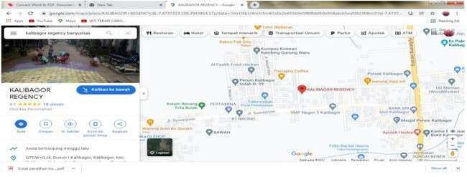

Figure 2.1 Map of Locations of Community Service Activities.

METHOD

Efforts to prevent the transmission of COVID-19 which are being carried out at Kalibagor Regency Housing, Kalibagor Village, Kalibagor Sub-District can be carried out, one of which is by using the socialization and application of the application of PHBS which will be carried out from April to August 2020.
This activity was carried out from April to August 2020, at the Kalibagor Regency Housing Complex, Kalibagor Village, Kalibagor District The method used is in the form of socialization on preventing the transmission of COVID-19 with PHBS with education through the WhatsApp (WA) group, installing posters and banners, distributing masks, and distributing simple hand washing facilities, distributing children's story books in the environment around Kalibagor Regency Housing, Kalibagor Village, District Kalibagor and conducting collaboration and collaboration with students of Gadjah Mada University Yogyakarta Real Work Lecture (KKN UGM) in 2020. As for the implementation of community service, the stages include:
a. Preparation Stage At the preparatory stage what was carried out were:
1) Coordination of community service team members: Aims to align the perceptions of members with the chairman. Coordination of members discussing matters general regarding the sustainability of the program, strategic steps to be taken, and dividing tasks to each member regarding the technical implementation of Community Service to be carried out at the Kalibagor Health Center.
2) Location survey: Conducted to see potential suitable places to carry out community service so that with community service it is expected to create an environmental atmosphere that describes PHBS in an effort to prevent transmission of COVID-19
3) Coordination with venues: Aims to align perceptions with the venue will be used as regional guidance in community service, get input in the implementation plan and discuss strategic steps in implementing community service in a sustainable manner.
4) Coordination with related parties: Aims to socialize the results of studies and observations and the importance of common perceptions in implementing PHBS in realizing efforts to prevent transmission of COVID-19.
5) Prepare community service equipment in the form of materials on PHBS, media posters, masks, simple hand washing facilities, banners to be placed in strategic places and story books for children.

b. Socialization
Stage At the socialization stage, the following were carried out:
1) Preparing permits, socialization materials and socialization equipment in the form of socialization equipment including posters, masks, simple hand washing facilities and story books, folders, and stationery equipment. The socialization will be carried out with the RW and RT heads as well as the RT level COVID-19 task force. Socialization materials include power point, and media posters, banners, story books and hand washing facilities as an application of PHBS in the framework of community service.
2) The socialization of the program aims to clarify the background, objectives and community service programs as an effort to prevent the spread of COVID-19 through PHBS at Kalibagor Regency Housing, Kalibagor Village, Kalibagor District. In this first socialization, the continuity of the community service program will be explained on the socialization of the results of the study in the Kalibagor Regency Housing area as an effort to prevent the spread of COVID-19, which targets all residents in the Kalibagor Regency Housing area, namely 36 houses.
c. Implementation Stage
The steps taken in the implementation phase include:
- Preparing permits and socialization materials: Preparing permits to invite a number of 5 RT administrators and representatives of the COVID-19 Task Force at Kalibagor Regency Housing and place permits. Prepare socialization material from the results of regional studies and observations.
- PHBS socialization aims to carry out efforts to prevent Covid-19. This socialization consisted of several stages, namely the provision of information from the results of studies that had been carried out at Kalibagor Regency Housing, discussions and questions and answers on how to prevent the transmission of COVID-19, discussions on installing media posters, banners and providing children's story books that support efforts to implement PHBS in in the context of efforts to prevent the transmission of COVID-19.
- Dissemination of the results of studies and observations in the Kalibagor Regency Residential area with the aim that PHBS can be implemented properly as an effort to prevent transmission of COVID-19
- Follow-up observations of the implementation of PHBS in each house in Kalibagor Regency Housing.

d. Evaluation Phase
At the evaluation stage, the following are carried out:
- Before the community service target socialization is carried out, first observations are made on community members in Kalibagor Regency Housing about PHBS for preventing transmission of COVID-19, so that you can find out about PHBS before carrying out community service.
- Conduct socialization on the implementation of PHBS in the Kalibagor Regency Housing area.
- After the socialization of community service objectives, assistance and observation were carried out regarding the implementation of PHBS for community members in the Kalibagor Regency Housing area, so that changes in clean and healthy living behavior in Kalibagor Regency Housing residents can be identified.
- Conduct an evaluation at each house to find out the implementation and application of PHBS as an effort to prevent the transmission of Covid-19.

- RESULTS AND DISCUSSION
The implementation method for preventing the transmission of Covid-19 through a clean and healthy lifestyle will be carried out in August and September 2020 at the Kalibagor Regency Housing Complex, Kalibagor District, Banyumas Regency, Central Java. Implementation of socialization and education aimed at all citizens who do not understand the prevention of Covid-19. The media and tools provided are in the form of posters and stickers, masks, hand washing facilities in the form of buckets, children's story books, juice and disinfectant for spraying the Kalibagor Regency residential environment. The method used is the socialization of preventing the transmission of COVID-19 with PHBS with education through the WhatsApp (WA) group, installing posters and stickers, distributing masks, and distributing handwashing facilities using buckets, distributing children's story books, juices, spraying the Kalibagor Regency housing environment and evaluation carried out in collaboration with UGM Yogyakarta KKN in 2020.
This community service activity was carried out in the form of socialization on the prevention of transmission of COVID-19 with PHBS through education conducted with the WhatsApp (WA) group, installing posters and stickers, distributing masks, and distributing simple hand washing facilities, distributing children's story books in the neighborhood around the housing complex. Kalibagor Regency, Kalibagor Village, Kalibagor Subdistrict and carried out collaboration and collaboration with students of the Gadjah Mada University Yogyakarta Real Work Lecture (KKN UGM) in 2020.
The results of the community service activities carried out at Perum Kalibagor Regency in detail can be described as follows:
- Education through the WhatsApp group (WA).
The education that was carried out through the WA group for the first time was by first coordinating with the RT group admins at Kalibagor Regency Housing and Kalibagor Indah Housing to provide information related to preventing the transmission of Covid-19. The results of coordination with the RW and RT parties said that there had not been anyone from the health department who had conducted education related to preventing the transmission of Covid-19, one of which was PHBS. There for it was suggested from the head of the RW to join the RT group which was then followed up by providing information about PHBS as a way to prevent COVID-19. The results of providing education to all members of the community who are in the good group in the Kalibagor Regency Housing RT group, totaling 25 Heads of families actively respond and feel happy and grateful for the information provided as well as the RT and RW management groups in Kalibagor Indah Housing which consists of 9 RTs with 5 RT administrators each also responding happily and gratefully for the information provided in the context of preventing the transmission of Covid-19 so that those who previously did not understand and did not know became more understanding and know how to prevent transmission of Covid-19 19 one of them is with PHBS
- Installation of posters and stickers
The results of the community service regarding the installation of posters and stickers regarding efforts to prevent the transmission of covid-19 through PHBS at Kalibagor Regency Housing, Kalibagor District, before the community service was carried out at Kalibagor Regency Housing, there were no posters or stickers related to efforts to prevent Covid-19 through PHBS, but after community service was carried out at the RT administrator's house, public places, stalls where posters were put up, a total of 30 posters, while for large stickers they were placed on carts of mobile vegetable vendors, and stalls about calling for the use of masks totaling 30 stickers, then for the stickers that are being installed on the handwashing buckets and for the small stickers that are installed on the liquid soap containers about the call for handwashing, totaling 40 stickers.

- Distribution of masks
Before the distribution of masks to residents in Kalibagor Regency Housing, the majority, both parents and children, did not have masks so that when they left the house and when the children were play they did not wear masks. However, after giving masks to the community at Kalibagor Regency Housing, most of the community members, both parents and children who left the house, had an awareness of wearing masks, as evidenced by the fact that when mothers were shopping for vegetables at mobile vegetable traders, their parents those who leave the house, and children who sometimes play together in front of the house already have the awareness to wear masks. The masks distributed to the community were cloth masks which were distributed to 30 heads of families in the Kalibagor Housing and its surroundings and distributed to itinerant vegetable traders, used goods collectors or scavengers and household garbage collectors in a total of 100 masks. From the results of observations in the implementation of community service, initially community members did not use masks as in religious activities, namely congregational prayers at the mosque, mothers who shop for vegetables did not use masks and children who played did not use masks, after community service activities so every member of the community who carries out religious activities, mothers who shop for vegetables, children who play and every member of the community who comes out of the Kalibagor Regency housing complex has become accustomed to always wearing a mask.
d. Distribution of hand washing facilities. Before the community service was carried out at the Kalibagor regency housing complex, based on the results of observations, there were only 2 houses that provided facilities for washing hands, and even then, they used gallons, and after the community service was carried out, all 25 heads of families were finally able to prepare hand washing facilities in front of each house and for the 15 hand washing facilities distributed around Kalibagor Regency Housing, namely in the Kalibagor Indah Housing area which are placed in strategic places such as RT security posts, RT level Covid-19 Task Force Post and some the stalls in the Kalibagor Indah Housing Complex.
e. Distribution of children's story books
Before the community service was carried out, the children did not have story books related to reading for children as an effort to prevent Covid-19, but after the community service regarding the distribution of story books to children was greeted with pleasure by both children and parents. It is evident from the children's story books that were distributed, it turns out that many have asked for them, but due to limitations in printing, in the end, the story books were not able to distribute soft files through the WA group of PKK RT mothers, so that they can be used by mothers as media stories about efforts to prevent Covid-19 19.
f. Cooperation in spraying disinfectant with the COVID-19
Task Force The implementation of spraying disinfectants carried out by each RT by the Covid-19 task force team has been running every week, so the community service team only follows the existing program and assists in the technical implementation.

The following is a picture of the implementation of the activity:
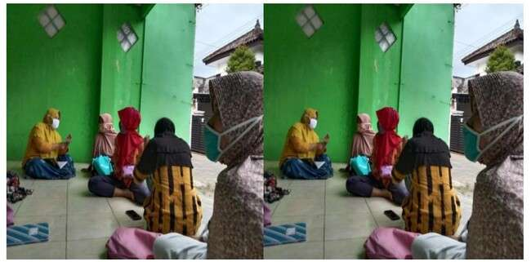

Figure 2.1 Photos of PKM activities explaining educational outreach via
WhatsApp (WA) media

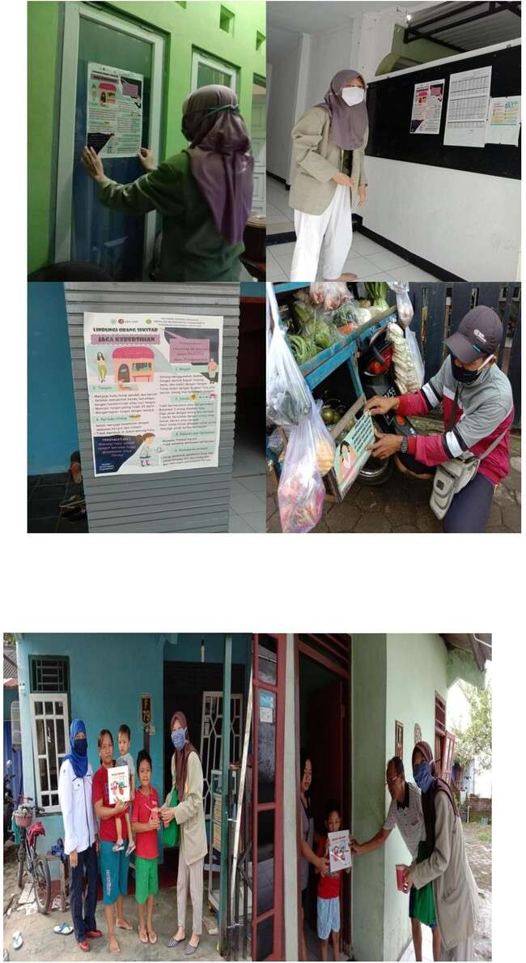

Figure 2.2 Photos of PKM activities posting posters and stickers in residents' homes and strategic places, bulletin boards and itinerant vegetable vendors

Figure 2.3 PKM activities distributing story books and fruit juices to children

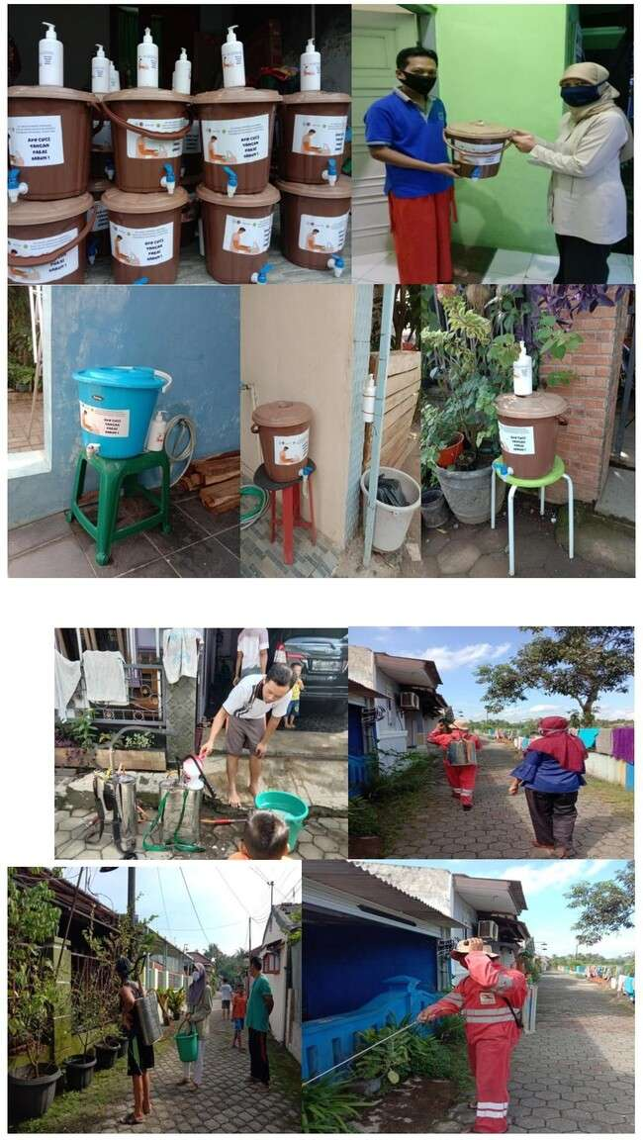

Figure 2.3 PKM activities distributing hand washing facilities to every resident in Kalibagor regency housing

Figure 2.4 PKM activities spraying disinfectant in every resident's house

- CONCLUSION
Coronaviruses are a large family of viruses that cause illness ranging from mild to severe symptoms. There are at least two types of corona virus that are known to cause diseases that can cause severe symptoms such as Middle East Respiratory Syndrome (MERS) and Severe Acute Respiratory Syndrome (SARS). Coronavirus Disease 2019 (COVID-19) is a new type of disease that has never been identified in humans before. The virus that causes COVID-19 is called Sars-CoV-2. This disease can only be prevented by means of PHBS, specifically by keeping a distance, wearing a mask and washing hands. The COVID-19 corona virus pandemic has yet to find drugs and vaccines. Therefore, only a healthy lifestyle can break the chain of COVID-19. Even the world health organization, WHO, urges the whole world to prioritize healthy living behaviors and the habit of washing hands. After the Corona virus status was raised by WHO to become a pandemic, it made us more aware of the importance of maintaining a healthy body. All members and organs of the body, including the lungs, heart, and so on, must always be kept healthy. This can be done by adopting a healthy lifestyle and maintaining cleanliness. By doing these things, we will get many benefits. In addition to a healthier body, we can also avoid viruses, one of which is the Corona virus.

- REFERENCES
Chen H, Guo J, Wang C, Luo F, Yu X, Zhang W, et al. (2020). Clinical Characteristics and Intrauterine Vertical Transmission Potential of COVID-19 Infection in Nine Pregnant Women: a Retrospective Review of Medical Records. Lancet. 395(10226):809-15.
Chen J, Qi T, Liu L, Ling Y, Qian Z, Li T, et al. (2020). Clinical Progression of Patients with COVID-19 in Shanghai, China. J Infect. Published online March 19. DOI: 10.1016/j.jinf.2020.03.004.
Indonesian CNN. (2020, March 14). Getting to Know Social Distancing as a Way to Prevent Corona. Indonesian CNN. Downloaded from https://www.cnnindonesia.com/gayahidup/20200314102823-255483358/mengenal-social-distancing- as-caramenprevent-corona
Guan WJ, Ni ZY, Hu Y, Liang WH, Ou CQ, He JX, et al. (2020). Clinical Characteristics of Coronavirus Disease 2019 in China. New Engl J Med. published online February 28. DOI: 10.1056/ NEJMoa2002032
Hariyadi, D. (2020, March 18). Corona Pandemic, Thousands of People Participate in Tabligh Akbar throughout Asia in Gowa. tempo.co. Downloaded from https://nasional.tempo.co/read/1321285/pandemicorona-ribuan-orang-ikut-tabligh-akbar-se-asia-di-gowa
Huang C, Wang Y, Li X, Ren L, Zhao J, Hu Y, et al. (2020). Clinical Features of Patients Infected with 2019 Novel Coronavirus in Wuhan, China. Lancet. 395(10223):497-506
Ministry of Health of the Republic of Indonesia. (2020). Info on Emerging Infections Ministry of Health of the Republic of Indonesia [Internet]. updated 2020 March 30; cited 2020 March 31. Available from: https:// infinemerging.kemkes.go.id/.
Malik, D. (2020, March 14). Anies Closes Tourist Locations in Jakarta, Tourists Move to Puncak, Bogor. Viva news. Downloaded from https://www.vivanews.com/berita/nasional/40497-anies-kapal-wisata-dijakarta-wisatawan-transfer-ke-puncak-bogor?medium=autonext

“2019 Novel Coronavirus (2019-nCoV)”. Centers for Disease Control and Prevention. 11 February 2020. Archived from the original on 7 March 2020. Retrieved 18 February 2020. The virus is thought to spread mainly from person-to-person through respiratory droplets produced when an infected person coughs or sneezes.
Ren L-L, Wang Y-M, Wu Z-Q, Xiang Z-C, Guo L, Xu T, et al. (2020). Identification of a Novel Coronavirus Causing Severe Pneumonia in Human: a Descriptive Study. Chin Med J. published online February 11. DOI: 10.1097/CM9.0000000000000722.
Rothan, H.A, & Byrareddy, S.N. (2020). The Epidemiology and Pathogenesis of Coronavirus Disease (COVID-19) Outbreak. J Autoimmune. Published online March 3. DOI: 10.1016/j.jaut.2020.102433.
Surface Stability of SARS-CoV-2 as Compared with SARS-CoV-1”. The New England Journal of Medicine. Massachusetts Medical Society. doi:10.1056/nejmc2004973. PMID 32182409.
Wang D, Hu B, Hu C, Zhu F, Liu X, Zhang J, et al. (2019). Clinical Characteristics of 138 Hospitalized Patients With 2019 Novel Coronavirus-Infected Pneumonia in Wuhan, China. JAMA. 2020; published online February 7. DOI: 10.1001/jama.2020.1585.
World Health Organization. (2020). Novel Coronavirus (2019-nCoV) Situation Report - 54 [Internet]. WHO [updated 2020 March 15; cited 2020 March 30]. Available from: https://www.who.int/docs/default-source/coronaviruse/situation-reports/20200314-sitrep-54-covid-19.pdf?sfvrsn=dcd46351_2.
World Health Organization. (2020). Report of the WHO-China Joint Mission on Coronavirus Disease 2019 (COVID-19). Geneva: World Health Organization.
World Health Organization. (2020). Clinical Management of Severe Acute Respiratory Infection when Novel Coronavirus (nCoV) Infection is Suspected. Geneva: World 58; Health Organization.
World Health Organization. Naming the coronavirus disease (COVID-19) and the virus that causes it [Internet]. Geneva: World Health Organization; 2020 [cited 2020 March 29]. Available from: https://www.who.int/emergencies/diseases/novelcoronavirus-2019/technical-guidance/naming-the-coronavirusdisease-(covid-2019)-and-the-virus-that-causes-it.
World Health Organization. (2020). Coronavirus Disease 2019 (COVID-19) Situation Report – 70 [Internet]. WHO; 2020 [updated 2020 March 30; cited 2020 March 31]. Available from: https://www.who.int/docs/default-source/coronaviruse/situation-reports/20200330-sitrep-70-covid-19.pdf?sfvrsn=7e0fe3f8_2

.

